WORKSHEET #12 - ECOLOGICAL SUCCESSION WORKSHEET

1. Based on the characteristics listed below, predict in what order each species of plant might appear and become established in a successional community. Be sure to explain your reasoning – which characteristics did you consider in formulating your prediction, and why?

|  |  |  |  |
| --- | --- | --- | --- |
| **Plant** | **Characteristics** | **Predicted timing**  **(Early, mid, late)** | **Reason** |
| Alder | Small deciduous tree. Bacteria in its roots fix nitrogen. Requires lots of sun. Wind dispersal, lots of seeds. |  |  |
| Big leaf maple | Large deciduous tree. Large seeds are wind dispersed. Grows slowly and is long lived. Requires rich organic soil. Somewhat shade tolerant. |  |  |
| Douglas fir | Large conifer. Low dispersal. Grows well in sun. Not shade tolerant. Reaches maturity at ~15 years. |  |  |
| *Dyras* | Small herbaceous plant. Short lived. Grows in high-light conditions in mineral soils. Bacteria in roots fix nitrogen. Light, fluffy seeds dispersed by wind. |  |  |
| Lichen | Fungus/algal combo. Photosynthetic. Obtains nutrients by breaking down rocks. Wind dispersed. |  |  |
| Spotted knapweed | Small herbaceous plant. Grows quickly and produces lots of small seeds. Tolerant of high light, low moisture, and nutrient poor soils. |  |  |
| Western red cedar | Large conifer. Long-lived and slow growing. Shade tolerant. Short distance dispersal |  |  |

*Continued on next page…*

1. Will abiotic or biotic factors be more important in determining the composition (which species establish there) of *early*-successional communities? Support your answer by providing specific examples of factors that would affect the species composition of an early successional community.
2. The follow questions refer to the figure below

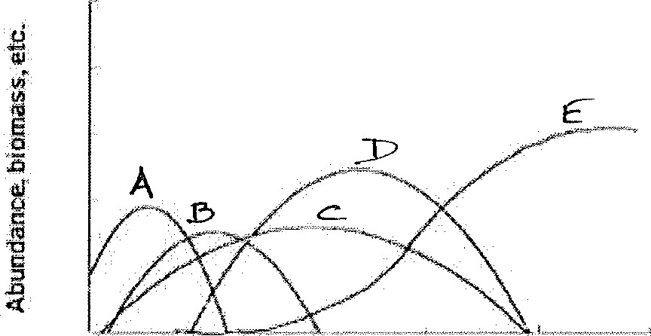

Time {Succession stage)

1. Provide one plausible explanation for the decrease in abundance of plant B.
2. List two possible life history traits for plant E.
3. Can plant E tolerate low light intensities? Explain your answer.